5.BOOK BANK PROCESS:

ACTIVITY DIAGRAM:

USECASE DIAGRAM:

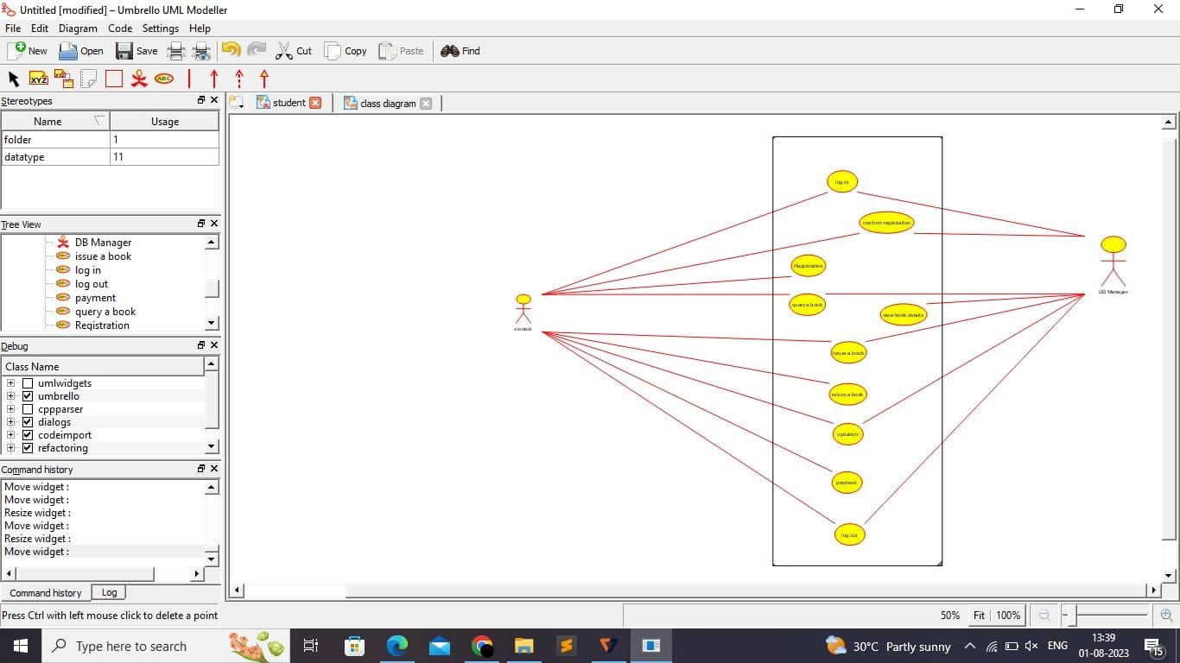

OBJECT DIAGRAM:

6.SOFTWARE PERSONAL MANAGEMENT SYSTEM

ACTIVITY DIAGRAM:

USECASE DIAGRAM:

OBJECT DIAGRAM:

7.E-BOOK MANAGEMENT SYSTEM:

ACTIVITY DIAGRAM:

USECASE DIAGRAM:

OBJECT DIAGRAM:

8.RECRUITMENT SYSTEM:

ACTIVITY DIAGRAM:

USECASE DIAGRAM:

OBJECT DIAGRAM: